HW 8 ECE 404
Nimal Padmanabhan
March 21, 2023

For this homework, we were tasked to do port scanning as well attempt to perform a DoS attack on another IP address. The script runs through all possible ports from 1 to 1024. For this assignment, I used the tcpdump utility in Linux to obtain ports being scanned as well as any network traffic that is happening between the two IP address (target and spoof). The ones highlighted below show the port scanning, and the ports are getting incremented each time.
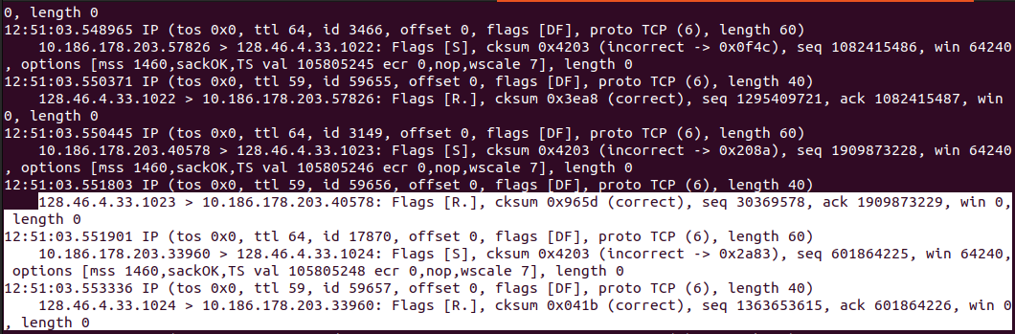
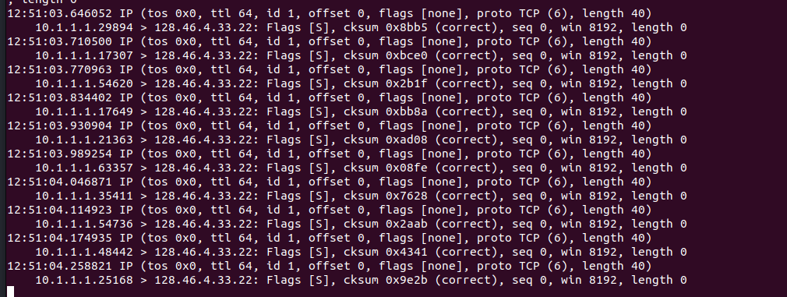

The figure above shows the attack done on a computer on the ececomp/eceprog network over 10 iterations. The left IP address is the spoof IP address followed by the target IP address.

